Wagon Captain | 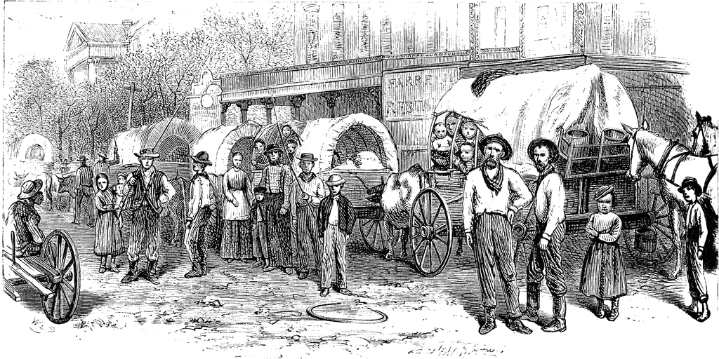

Select a route to your destination, then try and plan for problems faced by your company.
Departure Date, Route taken, Exact Destination:
____________________________________________________________________________________________________________________________________________________________________________________________________________________________________________________________________________________________________________________________________________________________________________________________________________________________________________________________________________________________________________________________________________________________________________________________________________

- Problem wagon trains face ________________________________________________________

  - Solution _______________________________________________________________________________________________________________________________________________________________________________________________________________________

- Problem wagon trains face ________________________________________________________

  - Solution ________________________________________________________________________________________________________________________________________________________________________________________________________________________

- Problem wagon trains face ________________________________________________________

  - Solution ________________________________________________________________________________________________________________________________________________________________________________________________________________________

- Problem wagon trains face ________________________________________________________

  - Solution ________________________________________________________________________________________________________________________________________________________________________________________________________________________

- Problem wagon trains face ________________________________________________________

  - Solution ________________________________________________________________________________________________________________________________________________________________________________________________________________________

- Problem wagon trains face ________________________________________________________

  - Solution ________________________________________________________________________________________________________________________________________________________________________________________________________________________

- Problem wagon trains face ________________________________________________________

  - Solution ________________________________________________________________________________________________________________________________________________________________________________________________________________________

