Monroe Doctrine
Directions: Look at the notes and watch the video on the Monroe Doctrine. Answer the following questions.
1. Summarize in a paragraph the Monroe Doctrine. What is it? Paragraph = 5-7 sentences, indent.

2. Analyze this Political Cartoon
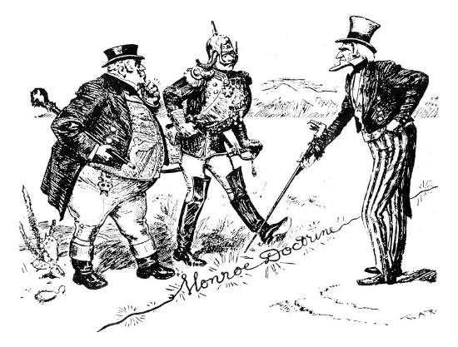
1. Describe what is happening in this cartoon.
2. Who is the figure on the right?
3. Who are the two figures on the left?
4. What is the figure on the right pointing to?
5. What is the message of the cartoon?

