Take me to a National Park | 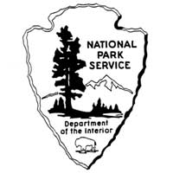
Directions: Use the Internet and book resources to re-search information about a national park. Use the topics below to guide your research.

Park Name:________________________________________________
State:______________________________________________________
Location: ___________________________________________________
Date Created: ______________________________________________
Geographical features (mountains, rivers, etc.): ______________________________________________________________________________________________________________________________________
Animals:_______________________________________________________________________________________________________________________________
Plants:________________________________________________________________________________________________________________________________
Other important facts: _________________________________________________________________________________________________________________________________________________________________________________________________________

