State Park Criteria Specialists
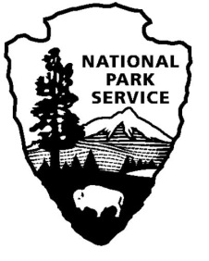

Directions: Use the Internet and book resources to re-search information about how to become a national park. Use the topics below to guide your research.

When and Why Yellowstone was created? ___________________________________________
______________________________________________________________________________
Which President was the first federal protection of wilderness? __________________________
_____________________________________________________________________________
Qualifications for national parks:__________________________________________________
____________________________________________________________________________________________________________________________________________________________
Historical Significance: ___________________________________________________________
________________________________________________________________________________________________________________________________________________________________________________________________________________________________________________________________________________________________________________________
Resource Evaluation: ____________________________________________________________
_________________________________________________________________________________________________________________________________________________________________________________________________________________________________________________________________________________________________________________

